How to run program in Codenvy

\*assuming everything is all set up

1. select build under CMD and press the run button. 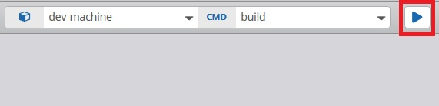
2. click on the blue link provided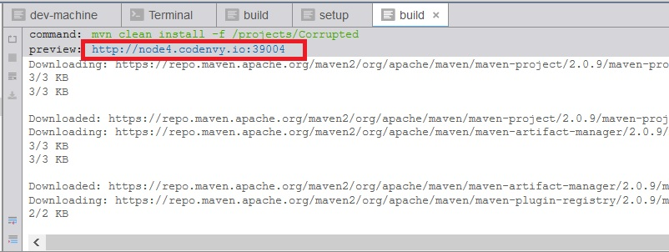
3. right click anywhere on the grey are and select terminal.
4. Run ./run.sh in the terminal

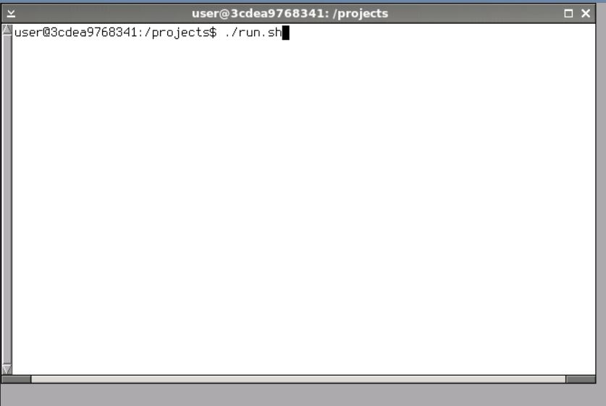

1. Close terminal and window when done.